Azure Analytics
- Azure Analysis Services
- Azure Data Explorer
- Azure Data Factory
- Azure Data Lake Storage
- Azure Databricks
- Azure Stream Analytics
- Azure Synapse Analytics
- Event Hubs
- Power BI

Azure Analysis Service

- Builds the model , with large amount of data around hundreds of GB’s
- The model is passed to Power BI for generating the charts
- Provides powerful tabular data models in the cloud
- Combines data from multiple sources into one semantic model
- It is for more specifically analytics part , while ADF is basically integration and movement (ETL)
- It is for structured/tabular data only

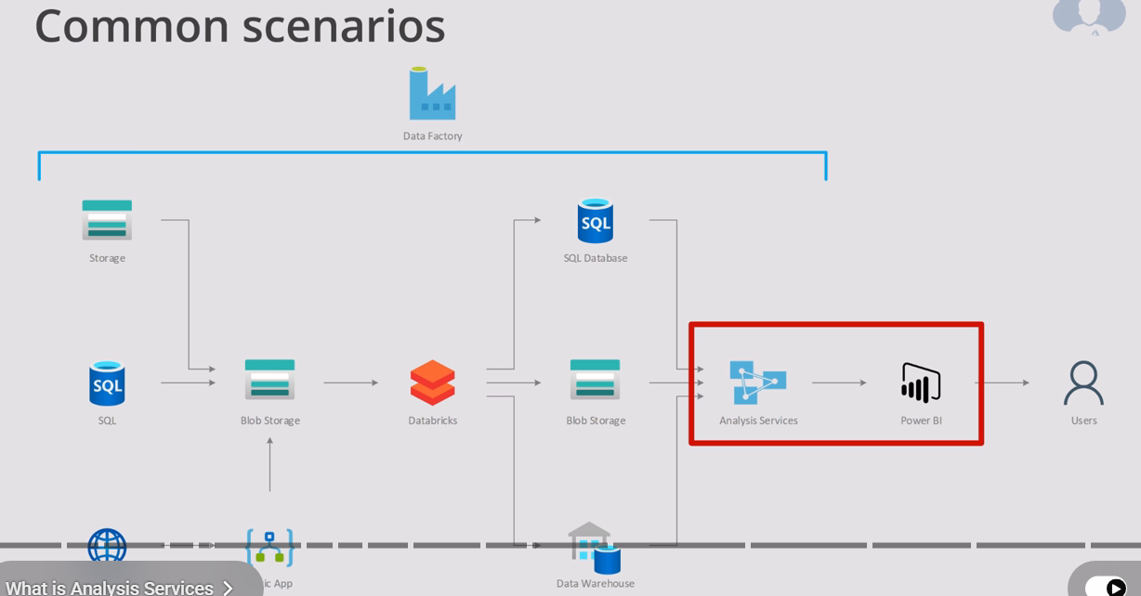
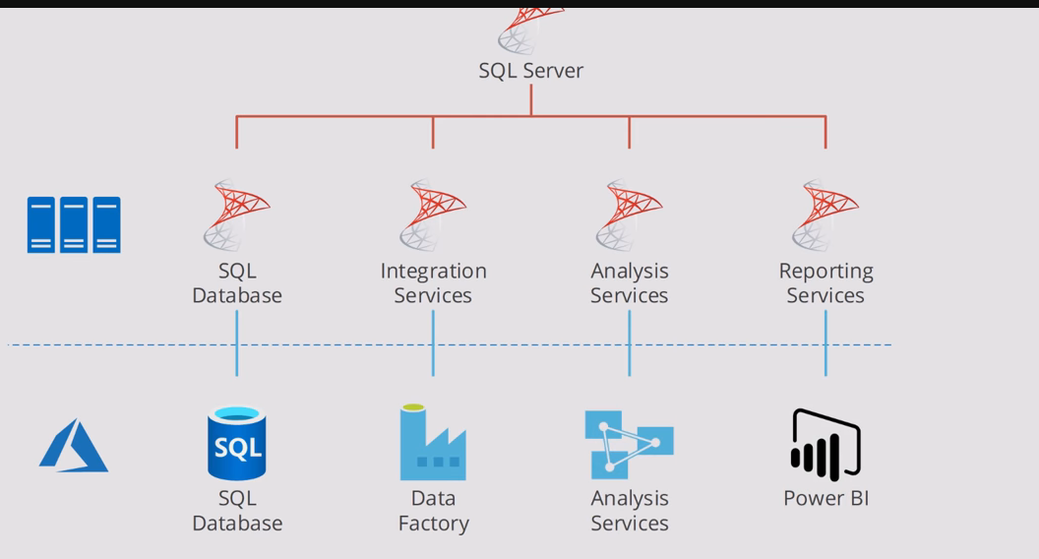

Azure Data Explorer
- Azure Data Explorer (ADX) , is built for real time , large scale data exploration (logs , telemetry , and IoT)
- Structured , semi – structured and unstructured data types
- Works with Power BI, Grafana, Synapse

Azure Data Factory
- It is Microsoft fully managed , serverless cloud based data integration service that enable you to build , schedule and orchestrate data pipelines for moving and transforming data across diverse sources at scale
- Data integration at scale

Azure data lake storage (ADLS)
- It is mircosoft cloud based storage solution designed specifically for big data analytics
- It provides massively scalable , secure and cost effective data lake where organizations can store structured , semi-structured and unstructured data of any size type
- Handles petabytes of data , scaling up or down as needed

Azure Databricks
- It is a cloud based , unified analytics and AI platform that combines big data processing , machine learning , and collaborative data science on top of the Apache spark engine . It’s designed to help organizations build , deploy and scale data pipelines , advanced analytics and AI solutions effectively .
- Built for big data engineering , machine learning , and advanced analytics

Azure Stream Analytics
- Designed for real time event processing. It ingests data from sources like IoT Hub , Event Hubs or Kafka , applies transformations and rules , and outputs results instantly to dashboard , alerts or storage
- It is built for real time stream processing , with low latency

Azure Synapse Analytics
- It is the central hub for enterprise scale analytics in Azure , combining the strengths of data warehousing , big data , and integration pipelines . It’s best when you need a single platform for querying , integration and visualizing massive datasets
- It stores and queries massive structured/unstructured datasets , integrates with data lakes , and supports SQL + Spart for analytics
- Data warehousing means storing large volumes of data from multiple sources in a centralized repository that is optimized for querying, analysis, and reporting—rather than for day-to-day transaction processing. Its main purpose is to provide clean, consistent, and historical data to support business intelligence and decision-making.

Event Hubs

- It is cloud based , real time ,data streaming platform , used to ingest , process and store millions of events per second from applications , devices and services . It’s primarily used for telemetry , logging IoT scenarios , and event drive architecture
- Can handle millions of events per second
- Streams data in near real time for immediate processing
- Stores events temporarily for replay and batch processing
- Event hubs are real time injection and buffering where as stream analytics is real time processing , they complement each other

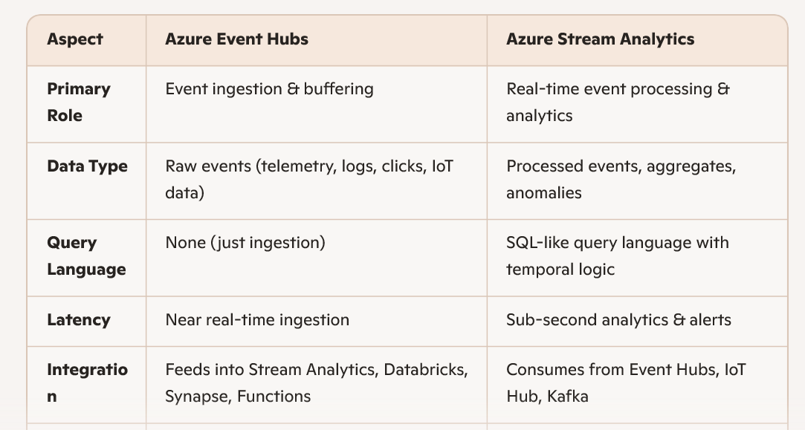

------------------------------------------------------------------------------------------------------------------

Difference between different analytical services .

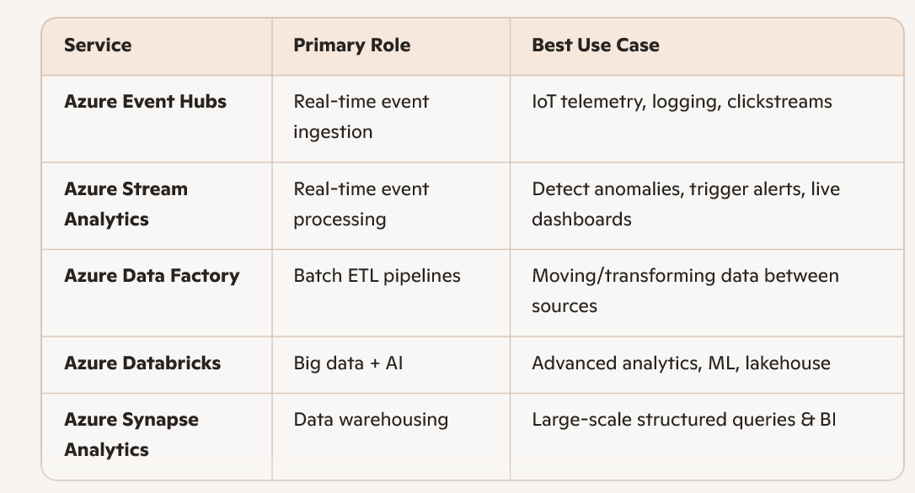

Azure Power BI
- It is business intelligence and data visualization platform that allows users to connect to multiple data sources , transform data , and create interactive dashboards and reports .
- It is widely used for turning raw data into actionable insights and integrates deeply with azure services
- Data connectivity: Connects to hundreds of sources (databases, cloud services, Excel, APIs).
- Data transformation: Built-in Power Query for cleaning and shaping data.
- Interactive dashboards: Drag-and-drop visuals, charts, maps, KPIs

